Document of the Inter-American Development Bank

**Mexico**

**Geothermal Financing and Risk Transfer Program**

**(ME-L1148)**

**Fourth Individual Operation Under the Conditional**

**Credit Line for Investment Projects (CCLIP) to Support Business Development in Mexico**

**(ME-X1010)**

**and**

**Investment Grant for the Geothermal Financing and Risk Transfer Program**

**(ME-G1005)**

**Economic Analysis**

**Content**

I. Introduction 3

II. Methodology and Assumptions 4

A. Methodology 4

B. Assumptions 6

III. Results of the Analysis 11

A. COST-EFFECTIVENESS ANALYSIS 11

B. COST-BENEFIT ANALYSIS 13

C. Economic Returns 15

IV. Sensitivity Analysis 15

V. Conclusions 16

Annex 1. Detailed annual cash flows – Cost-benefit analysis 17

annex 2. an illustrative case of government cost-sharing of exploration costs 18

1. Introduction  
   1. In the current context of global climate change, governments in emerging economies have to face the important challenge of responding to increasing demands for energy while maximizing their system’s security of supply, efficiency and sustainability. Investments in power generation from clean sources play a big role in this process, contributing to diversifying the countries’ energy matrixes and mitigating the negative environmental impacts of conventional power technologies.
   2. Mexico is the world’s thirteenth largest greenhouse gas (GHG) emitter and the second CO2 emitter in Latin America. The country has voluntarily committed to reducing its GHG emissions up to 30% by 2020, with respect to the business as usual scenario (LGCC)[1]. Almost 60% of the potential for these reductions comes from the energy sector, mainly transport and power generation. The LGCC also sets the specific target of achieving 35% of power generation from non-fossil-fuel-based sources of energy by 2024. But over 80% of Mexico’s electricity production still comes from fossil fuels, imposing the need for a transformation of the country’s power generation system in a sustainable and cost efficient way.
   3. According to a study carried out by INECC[2], the potential for GHG emissions abatement through clean energy generation by 2020 is 86 MtCO2e, equivalent to 23% of theoretical reduction potential identified. But despite Mexico’s great potential for the use of clean power sources, most of it still remains relatively untapped. The study shows that the marginal cost of abatement of some of these technologies (such as geothermal) is very low compared to those based on fossil fuels use.
   4. Geothermal energy offers one of the most effective renewable and low carbon alternatives for electricity generation, opening up the possibility of increasing the share of clean sources in Mexico’s energy matrix. Furthermore, the role of geothermal power goes beyond its environmental contribution because it can produce significant economic and social benefits.
   5. The objective of the program is to increase power production from geothermal sources so as to contribute to the diversification of the energy matrix and reduce dependency on fossil fuels and GHG emissions in Mexico. To this end, the program intends to scale up investments in geothermal power generation projects by making available a range of financial mechanisms tailored to meet the specific needs for each project’s stage of development. This will include risk mitigation mechanisms as well as various forms of financing for exploration, drilling, field development and construction phases of geothermal projects.
2. Methodology and Assumptions
3. Methodology
   1. Evidence on the economic viability of the proposed program is presented below, based on: (i) a cost-effectiveness analysis of the proposed intervention with different alternatives existing in the recent literature; and (ii) a cost-benefit analysis focused on the objective of the program, namely, the increase in geothermal energy production, valued by its savings in electricity generation and the reduction of GHG emissions.
   2. The economic analysis for the proposed intervention then presents two main results:
      1. A standard cost-effectiveness ratio, comparing the total investment of the program per CO2 unit abated to other types of interventions.
      2. A value of the net benefits obtained by comparing the actual expected costs of the intervention and the monetized value of the benefits, i.e. energy savings and GHG emissions reductions from the use of geothermal plants that would not have existed in the absence of the program. The above characteristics are measured during a period of 30 years (estimated lifetime of projects financed by the program) and discounted at a rate of 12%.
   3. The basic information to estimate the costs and benefits of the program includes:
      1. **Classification of benefits.** The information for calculating the benefits of the program come from the power generation capacity installed via the projects financed and their contribution to reduction of GHG emissions. The Results Matrix outlines the indicators and the means to verify their performance. Based on these targets, the benefits considered consist of (for more detail on the calculations see **Section III: *Economic Benefits and Costs*** below):
         * 1. The savings in electricity generation as a result of the use of geothermal plants. This is estimated by calculating the difference among the levelized[3] generation cost of geothermal energy and the pool of renewable energies in Mexico[4].
           2. The expected GHG emissions reduced (number of metric tons of CO2 equivalent emissions averted) by the plants financed by the program. The characteristics of the technology financed (production factor, expected operating lifetime) makes it possible to make electricity generation estimations over a period of time, which will allow us to determine the GHG emissions that will be averted. This calculation depends on a number of assumptions but should give us a reasonably accurate measure of the overall impact.
      2. **Classification of costs (please see Assumption xiii below).** The basic information for estimating the costs of the program comes from the financial terms of the overall resources to be disbursed for the program, namely: i) the Inter-American Development Bank (IDB) loan for USD 54.3 million; ii) the Clean Technology Fund (CTF) concessional loan for USD 34.3 million; iii) the Clean Technology Fund (CTF) contingent recovery grants for USD 20 million; and the local counterpart USD 11.5 million[5]. We have to take into account that, from these, USD 3 million will be dedicated to Implementation costs and Technical Assistance activities, so the total program investment amount adds up USD 117 million[6].
   4. In sum, the analysis presented revises data and calculates estimations based on assumptions that allow us to assign values to key parameters with and without program. This model is used as a practical tool for calculating:
      1. A monetary value of the savings in electricity generation of the geothermal plants financed by the program compared to the generation costs of the pool of renewable energies in Mexico;
      2. A monetary value of the total reduction in metric tons of CO2e achieved through the use of geothermal energy developed as a result of funding from the program, based on the international market price of a ton of CO2;
      3. A monetary value of the total CTF/IDB/local resources invested, based on the terms and costs established in the proposed program.
   5. The cash flows of annual benefits and costs, as detailed above, are then discounted at a rate of 12% (standard for IDB programs) in order to obtain a Net Present Value (NPV), as an indicator of the economic viability of the program.
   6. Finally, this document includes an evaluation of the tolerance of the analysis in regards to the parameters used for the valuation of benefits. This sensitivity analysis is made considering variations in three criteria, independently, as follows: i) load capacity factor[7] of geothermal plants, ii) cost of pool energies; and iii) price of the metric ton of CO2 in the international markets (see **Section IV: *Sensitivity Analysis***).
4. Assumptions
   1. The main assumptions for the estimation of benefits and costs of this project are:

*Assumptions related to power saving with geothermal technology:*

1. **Geothermal Potential**
2. Mexico is the fourth largest country in geothermal generation with 890 Mw installed. It is expected that by 2020 geothermal capacity exceeds 1000 Mw, representing a 23% growth from 2010 to 2020[8]. The program is expected to finance projects that will contribute with 300 MW to the total geothermal capacity installed.
3. Following the classification of Benderitter and Cormy[9] (1990),

**Table 2.1. Classification of Geothermal Projects**

|  |  |  |
| --- | --- | --- |
| Entalphy | Temperature | General Applications |
| Low enthalpy | <100 oC | Thermal uses |
| Intermediate | 100-200 oC | Electric Generation (T>1500C)  Thermic uses |
| High enthalpy | >200 oC | Electric Generation |

High enthalpy resources are needed to generate electricity. Studies conducted over more than 30 years coincide with the great potential of Mexico regarding geothermal resources. The three most recent studies[10] show that there is enough potential for 300 MW:

**Chart 2.1. High Temperature Resources (Mw)**

1. **Geothermal Areas: potential pipeline**
2. The country’s potential and its distribution have been studied and several areas with geothermal resources have been identified. Table 2.2 shows the list of geothermal areas.

**Table 2.2. Geothermal Areas**

|  |  |  |  |
| --- | --- | --- | --- |
| Geothermal Area | State | Potential Estimation | |
| **Probable** | **90%** |
| 1. La Soledad | Jalisco | 52 | 10-94 |
| 2. Las Planillas | Jalisco | 70 | 26 – 113 |
| 3. Pathé | Hidalgo | 33 | 6 – 61 |
| 4. Araró | Michoacán | 21 | 5 – 37 |
| 5. Acoculco | Puebla | 107 | 38 – 177 |
| 6. Ixtlán de los Hervores | Michoacán | 17 | 0 – 23 |
| 7. Los Negritos | Michoacán | 24 | 3 – 44 |
| 8. Volcán Ceboruco | Nayarit | 74 | 34 – 113 |
| 9. Graben de Compostela | Nayarit | 105 | 35 – 175 |
| 10. San Antonio El Bravo (Ojinaga) | Chihuahua | 27 | 10 – 43 |
| 11. Maguarichic | Chihuahua | 1 | 0.2 – 1.7 |
| 12. Puruándiro | Michoacán | 10 | 3 – 17 |
| 13. Volcán Tacaná | Chiapas | 60 | 21 – 99 |
| 14. El Orito-Los Borbollones | Jalisco | 11 | 1 – 21 |
| 15. Santa Cruz de Atistique | Jalisco | 12 | 2 – 22 |
| 16. Volcán Chichonal | Chiapas | 46 | 9 – 84 |
| 17. Hervores de la Vega | Jalisco | 45 | 20 – 71 |
| 18. Los Hervores-El Molote | Nayarit | 36 | 12 – 59 |
| 19. San Bartolomé de los Baños | Guanajuato | 7 | 3 – 12 |
| 20. Santiago Papasquiaro | Durango | 4 | 1 – 7 |

For practical purposes, the analysis assumes the 300 MW will be developed in six geothermal plants, with an average of 50 MW of capacity installed each. The program will in fact finance up to 15 projects of which the remaining 9 will fail to reach a commercial stage of power generation.

1. **Geothermal power generation**
2. The development of a geothermal power plant can be divided into four stages: Exploration, Confirmation and Drilling, Construction, and Operation and Maintenance.

**Figure 2.1. Phases of a geothermal project**

|  |  |  |  |
| --- | --- | --- | --- |
| ≈2 years | ≈4 years | ≈3 years | 30+ years |

1. In accordance with the program targets, six (6) of the geothermal projects that will be financed at some stage by the program will be successful, i.e. they will move on from exploration and production drilling to operation (they will end up producing electricity). For the purpose of this analysis, we assume the following calendar:

**Table 2.3. Calendar of implementation of the program**

|  |  |  |  |  |  |  |  |  |  |  |  |  |
| --- | --- | --- | --- | --- | --- | --- | --- | --- | --- | --- | --- | --- |
| Project | 2015 | 2016 | 2017 | 2018 | 2019 | 2020 | 2021 | 2022 | 2023 | 2024 | … | 2044 |
| Geothermal 1 |  |  |  |  |  |  |  |  |  |  |  |  |
| Geothermal 2 |  |  |  |  |  |  |  |  |  |  |  |  |
| Geothermal 3 |  |  |  |  |  |  |  |  |  |  |  |  |
| Geothermal 4 |  |  |  |  |  |  |  |  |  |  |  |  |
| Geothermal 5 |  |  |  |  |  |  |  |  |  |  |  |  |
| Geothermal 6 |  |  |  |  |  |  |  |  |  |  |  |  |
| Investment |  |  |  |  |  |  |  |  |  |  |  |  |

|  |  |
| --- | --- |
| **Investment** | **Benefits** |

*Source: Developed by author, 2013*

1. Investment costs for a high heat geothermal plant are estimated on US$4 million per MW (PwC, 2012)[11]. The levelized cost[12] of a geothermal plant is 93 USD/Mwh[13]. This cost is calculated based on the COPAR[14] methodology with the following hypothesis adopted to the Mexican context,
   1. Success ratio of drilling: 67%
   2. Average power of each well: 5 MW
   3. Average depth: 2,000 meters
   4. Lifespan: 30 years
2. We assume an 84% load capacity for geothermal projects in Mexico[15].
3. **Renewable power generation in Mexico**
4. To estimate the costs of renewable energy generation in Mexico, we use current costs of renewable energy (as of 2012).

|  |  |  |  |
| --- | --- | --- | --- |
| inoPlant | USD/Mwh | | |
|  | Investment | O&M | **Total** |
| Geothermal Power | 65 | 28 | **93** |
| Solar Energy | 182,12 | 7,63 | **189,74** |
| Hydro Power | 110,37 | 9,35 | **119,72** |
| Wind Power | 72,575 | 8,585 | **81,16** |

*Source: (Solar, Water and Wind Power) CFE.* [*Costos y Parámetros de Referencia para la Formulación de* *Proyectos de Inversión en el Sector Eléctrico*](http://idbdocs.iadb.org/wsdocs/getDocument.aspx?Docnum=38271058)*. 2012.*

1. In 2011, Mexico generated renewable electricity in the following percentages[16]:

**Chart 2.2. Distribution of renewable energy in Mexico (excluding geothermal)**

*Source: SENER (2011). Prospectiva del Mercado de Gas Natural 2012-2026*

*Assumptions related to CO2 emissions and energy and water consumption:*

1. The reductions in CO2 emissions because of new geothermal capacity installed as a result of the program are indicated in Table 2.5. For the calculations of CO2 emissions, the analysis uses the standard IDB methodology, assuming an average emissions factor for electricity in Mexico of 0.5 MTCO2/MWh.

**Table 2.5: CO2 reductions by geothermal plants**

|  |  |  |  |  |  |  |  |  |  |  |
| --- | --- | --- | --- | --- | --- | --- | --- | --- | --- | --- |
| Project | 2015 | 2016 | 2017 | 2018 | 2019 | 2020 | 2021 | 2022 | 2023 | 2024 |
| Annual emission reduction (MTCO2) | - | 183.960 | 183.960 | 367.920 | 367.920 | 545.144 | 735.840 | 735.840 | 919.800 | 1.103.760 |

*Source: Developed by author, 2013*

1. The market price per metric ton of CO2 is USD 5.88. Its valuation is calculated using public information on its unitary price in international markets;[17]

*Assumptions related to the costs of the program:*

1. The financing terms for each of the four co financers are:

|  |  |  |  |  |  |  |
| --- | --- | --- | --- | --- | --- | --- |
|  | **Table 2.6.- Costs of the program by source and component (USD million)**[18] | | | | | |
| **Cost component** | | **IDB**[19] | **CTF** | **Local**[20] | **Private** | **Total** |
| **Total financing** | | 54.3 | 54.3 | 11.5 | --- | **120** |
| **(-) Implementation costs and Technical Assistance activities** | | --- | (3.0) | --- | --- | (3) |
| **Total Cost of the Program** | | 54.3 | 51.3 | 11.5 | --- | **117** |
| **Total Investment** | | 54.3 | 51.3 | 11.5 | 1,083.0 | **1,200** |

1. We use a general, “heroic”, assumption to avoid the presentation of a full set of assumptions over the characteristics of 15 projects: the cost of the private investment will be 100% offset by the private benefit and the public resources spent. The LCE concept universally used in energy investments planning encapsulates this assumption (it is the unit cost that makes the investment profitable). However, we provide the full range of costs of a standard 50 MW geothermal plant, enclosed in Annex 2, taken from the “Geothermal Handbook: Planning and Financing Power Generation” of the ESMAP.
2. We have to take into account that USD 3 million will be dedicated to Implementation costs and Technical Assistance activities, so the Total Cost of the Program amount adds up USD 117 million.
3. It is assumed that the investment/disbursement of funds occurs in a period of 6 years, in accordance to the execution period of the program.

*Additional general assumptions:*

1. The timespan to analyze the benefits will be 30 years which is a conservative estimate of the life of a geothermal plant.
2. The average exchange rate is 13.11 MXN/USD or 0.076 USD/MXN. The exchange rate between dollars and euros is 0.74 EUR/USD or 1.36USD/EUR.
3. For the benefits estimated in this analysis to be accomplished, it is assumed that the economy of the country will keep a framework that ensures appropriate conditions for consumption and investment, both public and private.
4. Additional benefits derived from developing 300 MW of geothermal power are not included in the analysis. These involve positive economic and social impacts[21] that are considered co-benefits and include:
   1. It would increase 0.10% the GDP once the 300 Mw are in operation.
   2. Generate more than 5.400 jobs throughout 30 years.
   3. It would increment the security of supply by reducing a 2% of the imports of natural gas in 2020.
   4. It will help generating value-added industry.
5. Results of the Analysis
6. COST-EFFECTIVENESS ANALYSIS
   1. Table 3.1 below presents the results of the cost-effectiveness analysis. It is expected that the geothermal plants financed by the program, once fully operative, will deliver an annual average production of 2.2 MMWH and over 30 MMT of CO2 emissions reductions over the life of the projects (30 years).
   2. Production is calculated applying the prevalent utilization factor for Mexico. Net emissions results are calculated using internal IDB tools deducting the emissions caused by the construction of the plants and by the destruction of landmass cover from the gross emissions reductions.
   3. This implies a unit abatement cost of 1.64 USD per Metric Ton considering total CTF investment. These results are in line with previous CTF interventions.

**Table 3.1. Main results cost-efficiency analysis**

|  |  |  |  |
| --- | --- | --- | --- |
| Technical Factors | | Financial Factors | |
| MW installed | 300 | Total Program Investment (MUSD) | 117.1 |
| Total Investment per MW installed (MUSD) | 4.0 | IDB Investment | 54.3 |
| Annual Production (Gwh) | 2.2 | CTF Investment | 54.3 |
|  | | Local Investment | 11.5 |
| Annual CO2 emissions averted MT 1.103.760 | | (CO2TM) | |
| Total MT emissions averted 30 years 33.112.800 | | (CO2TM) | |
| CTF cost per emission averted (USD/CO2TM) | | 1.64 | |
| Program cost per emission averted (USD/CO2TM) | | 3.53 | |
| Total investment per emission averted (USD/CO2TM) | | 36.24 | |

*Soruce: Developed by author, 2013*

* 1. The [Low-Carbon Development for México](http://bit.ly/lcdmex) (Johnson et al., 2009) study, published by the World Bank, assesses the cost-effectiveness (in terms of dollars per ton of CO2) for a number of mitigation interventions in Mexico, from an economic point of view (see Figure 3.1).
  2. According to this study, renewable energy-based electricity generation technologies have net mitigation costs between -2.4 and 11.7 USD/tCO2e (see Table 3.2).

**Figure 3.1. Marginal Abatement Cost Curve**

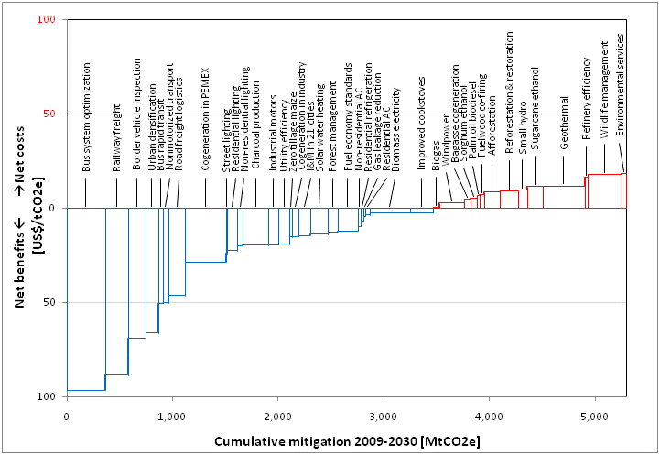

*Soruce: Johnson et al, 2009*

**Table 3.2. Mitigation costs for renewable energy technologies**

|  |  |  |
| --- | --- | --- |
| Interventions | Maximum annual emission reduction (MtCO2e/year) | Net cost or benefit of mitigation (US$/tCO2e) |
| Biomass electricity | 35.1 | 2.4 (benefit) |
| Biogas | 5.4 | 0.6 (cost) |
| Windpower | 23 | 2.6 (cost) |
| Bagasse cogeneration | 6 | 4.9 (cost) |
| Fuelwood co-firing retrofitting | 2.4 | 7.3 (cost) |
| Small hydropower | 8.8 | 9.4 (cost) |
| Geothermal power | 48 | 11.7 (cost) |

*Source: Johnson et al, 2009*

* 1. Despite the fact that the mitigation costs of renewable energy technologies are relatively high as compared to other options located on the left side of Figure 3.1, they are cost-effective due to the following reasons:
     1. Firstly, the mitigation costs reported in the study “do not include the additional organizational and institutional interventions that might be required to overcome barriers to implementing an option”. The negative costs therefore “suggest the presence of barriers that prevent private parties or public agencies from acting in a way that cost-effectiveness calculations suggest makes economic sense”. Unlike the interventions located on the left side of Figure 3.1, which face significant imperfect-market barriers, renewable energy technologies benefit today from a favorable regulatory framework that has contributed to removing barriers.
     2. Renewable Energy investments provide the country with a number of development co-benefits (in addition to the climate mitigation benefits). In particular they contribute to the diversification of the energy matrix, the reduction of fossil fuels imports (notably natural gas), and the reduction in the exposure to fossil fuel price volatility risks.

1. COST-BENEFIT ANALYSIS

Economic Benefits

* 1. **Benefit A: Savings on geothermal power generation**. The major impact of the program is focused on the savings by the generation of electricity with geothermal plants compared to other type of renewable energy[22].
  2. The cost of the pool of renewable energies weighted by its share of generation in Mexico (see assumptions 2.8.i to 2.8.x) is,

So,

* 1. The Benefit A will be the difference between the costs of generation of electricity with geothermal technology and the costs of generation with a representative pool of the renewable energies in Mexico.

Where:

* 1. **Benefit B: Reduction in CO2 emissions generated by geothermal plants financed by the program.** The primary impact of the renewable energies is focused on its contribution to the overall reduction in GHG emissions. In order to quantify this benefit in our program, the total amount of CO2 emissions averted, expected from the construction of geothermal plants with funds from the program, is multiplied by the international market price of the MT of CO2. The metric tons of CO2 reduced are calculated using the accumulated number of plants financed. The total benefit from the emissions reduced is calculated for a period of 30 years, as follows:

*Benefit B = PxMTCO2 × REDY × NY*

Where:

PxMTCO2 (USD) = International market price on 1 metric ton of CO2

NY = Number of plants financed by the program

REDY (MTCO2) = CO2 metric tons reduced per plant

* 1. The global benefit of the program will then be the sum of the two criteria described above, resulting on total annual flows projected for a period of 30 years.

$$B=\sum{Benefit A+Benenfit B}$$

Economic Costs

**Costs** **(see assumptions)** As described in the POD, the Bank, acting as an executing agency for the Clean Technology Fund (CTF), will disburse USD 20 million of CTF resources from the DPSP, USD 34.3 million of CTF Funds from Mexico’s IP, as well as USD 54.3 million from the Bank's existing CCLIP (ME-X1010) that will fund geothermal projects. The local counterpart will collaborate with USD 11.5 million[23]. We have to take into account that around USD 3 million will be dedicated to Implementation costs and Technical Assistance activities, so the total investment amount for the program adds up USD 117 million. This amount, with the associated costs and terms from the agents that participate in the operation, result on total annual cost flows, projected for a period of 30 years.

1. Economic Returns
   1. Based on the calculations of costs and benefits detailed above, the net cash flows discounted at a rate of 12% produce a net present value (NPV) for the program of USD 194.53 million (see Table 3.3). A detailed chart with the calculations is annexed at the end of this document.

**Table 3.3: Summary of Benefits and Costs Analysis**

|  |  |
| --- | --- |
| NPV per concept | (MUSD) |
| Electricity Saving | 245.54 |
| Total CO2 reductions | 29.23 |
| Total costs | (80.24) |
| Net NPV | **194.53** |

*Source: Developed by author, 2013*

* 1. As it can be seen in the chart above, the program would be considered viable even if we only consider the direct benefits related to electricity savings in its generation (some indirect benefits are mentioned in assumption xix and point 3.6 b).
  2. It is important to mention also that, in addition to the benefits considered in this analysis, the project is expected to have a substantial demonstration effect on the private sector investors and developers.

1. Sensitivity Analysis
   1. Complementary to these results, a sensitivity analysis is included in this section, where variations on key parameters (load factor, as a proxy to total production/capacity installed, cost of other renewable technologies, and CO2 price) are simulated to gauge their impact on the benefits. In other words, values are stressed in order to verify the tolerance of the program to variations on the conditions that may have an impact on the results established above.
   2. The parameters that were changed for the sensitivity analysis and each of their breakeven values (minimum values for the program to remain viable, based on the analysis of the program NPV, discounting flows at a 12% rate), are shown in the table below. Hence, the program would become unviable only if the values of any of these variables, independently, were equal to or less than the figures indicated below (except for the international market price per metric ton of CO2, which is set at a minimum value of zero).

**Table 4.1: Summary of Sensitivity Analysis**

|  |  |  |  |  |
| --- | --- | --- | --- | --- |
| Parameter that was changed | Value Used for Economic Returns Estimations | New Value for Sensitivity Analysis | NPV with the new value (MUSD) | Variation in parameter (%) |
| Load capacity factor[24] | 84% | 24.5% | 0 | **-70.4%** |
| Cost of pool of energies | 117.69 USD/Mwh | 98.13 USD/Mwh | 0 | **-16.62%** |
| PxMTCO2 (USD) | 5.88 | 0 | 165.30 | **- 100%** |

*Source: Developed by author, 2013*

1. Conclusions
   1. The cost benefit analysis shows how the discounted benefits are greater than the discounted costs, thus resulting in a positive net present value (NPV).
   2. With regards to the benefits of the program, the NPV of the two benefits considered (see **Section III: *Results of the Analysis*** for more detail), add up to a total of USD 274.77 million. This amount represents a higher value than that of the discounted flows from the total costs of the program, which result on USD 80.24 million. Hence, the monetary net benefits of the program are estimated on USD 194.53 million. In addition, the sensitivity analysis shows that even when changing the value of the parameters used for the calculations, the program remains viable for a wide range of values.
   3. There are relevant factors that entail rather prudent and conservative calculations for this analysis, which are likely to have resulted on an underestimation of the real benefits of the program.
   4. In general, the project team has used plausible and contrasted assumptions, with aims of a conservative approach for the analysis. Based on this, the project team recommends the Bank approves the financing of this program.

Annex 1. Detailed annual cash flows – Cost-benefit analysis



ANNEX 2. AN ILLUSTRATIVE CASE OF GOVERNMENT COST-SHARING OF EXPLORATION COSTS

**METHODOLOGY**

The illustrative ﬁnancial analysis of a hypothetical 50 MW geothermal project used in this handbook is based on a customized Excel spreadsheet model. The model calculates the internal rate of return (IRR) on the project and its net present value (NPV), as well as the rate of return on equity investment and its respective NPV. These are common decision making criteria in project ﬁnance. In addition, the model calculates the levelized cost of energy (LCOE), although it is not an integral part of the return and NPV calculations. The LCOE is calculated as the discounted stream of project costs (including both capital and operating expenses) over the life of the project, divided by the stream of corresponding energy outputs discounted by the same discount rate.

The dollar amounts are given in real terms. To convert the results into nominal terms, escalation factors would need to be introduced for all cost items as well as for the tariff. The NPV on the project and its respective IRR take the perspective of all investors, including the suppliers of debt (lenders). The cash ﬂow used in this part of the caclulation is based on the concept known in project ﬁnance as free cash ﬂow, sometimes deﬁned more speciﬁcally as the free cash ﬂow to the ﬁrm (FCFF). In our case the “ﬁrm” is the project, so the cash ﬂow is denoted as free cash ﬂow to the project (FCFP). The formula to determine the project NPV is:

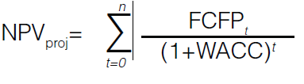

where FCFPt is the free cash ﬂow to the project in year t in the project life of n years; WACC is the weighted average cost of capital. WACC is found by the formula WACC = interest rate of the debt x (1– corporate tax rate) x proportion of debt in the project capital + (required rate of return on equity x proportion of equity in the project capital). When grants are included, they reduce the amount of capital to be covered by debt and equity.

The NPV of the cash ﬂow to equity and the respective rate of return take the perspective of equity investors only. The cash ﬂow used in this caclulation is based on the concept of free cash ﬂow to equity (FCFE). The formula to determine the equity NPV is:

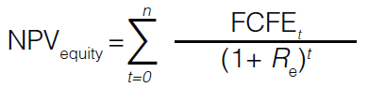

where FCFEt is the free cash ﬂow to equity in year t in the project life of n years; and Re is the required return on equity. Discounting by Re (rather than by WACC) is consistent with the fact that the annual interest and principal payments for the debt are already made and the entire remaining cash ﬂow belongs to the equity investors. The latter generally require a higher return from this cash ﬂow to compensate for the higher risk associated with being the last in line to receive the payoff.

The level of the risk premium and the resulting Re depends strongly on the nature of the project. As noted in this book, common equity investors in a geothermal project may require a return between 20 and 30 percent. However, as also noted in Chapter 3, this can be lowered by proper cost sharing arrangements. Partial grant support from the government during the crucial early stages of the project, for example, may reduce the required rate of return considerably.

**SUMMARY TABLES**

**A Hypothetical Geothermal Project - Financial Analysis**

Abbreviations used in this annex:

|  |  |
| --- | --- |
| Capex | Capital expenditures (or investment costs) |
| EBIT | Earnings before interest and taxes |
| EBITDA | Earnings before interest, taxes, and depreciation/amortization |
| FCFE | Free cash ﬂow to equity |
| FCFP | Free cash ﬂow to the project |
| IRR | Internal rate of return |
| NPV | Net present value |
| O&M | Operation and maintenance costs |
| PV | Present value |
| R e | Required rate of return on equity |
| WACC | Weighted average cost of capital |

YEARS 7...30

**SUMMARY TABLES**

A Hypothetical Geothermal Project - Financial Analysis (constant 2011 US$)



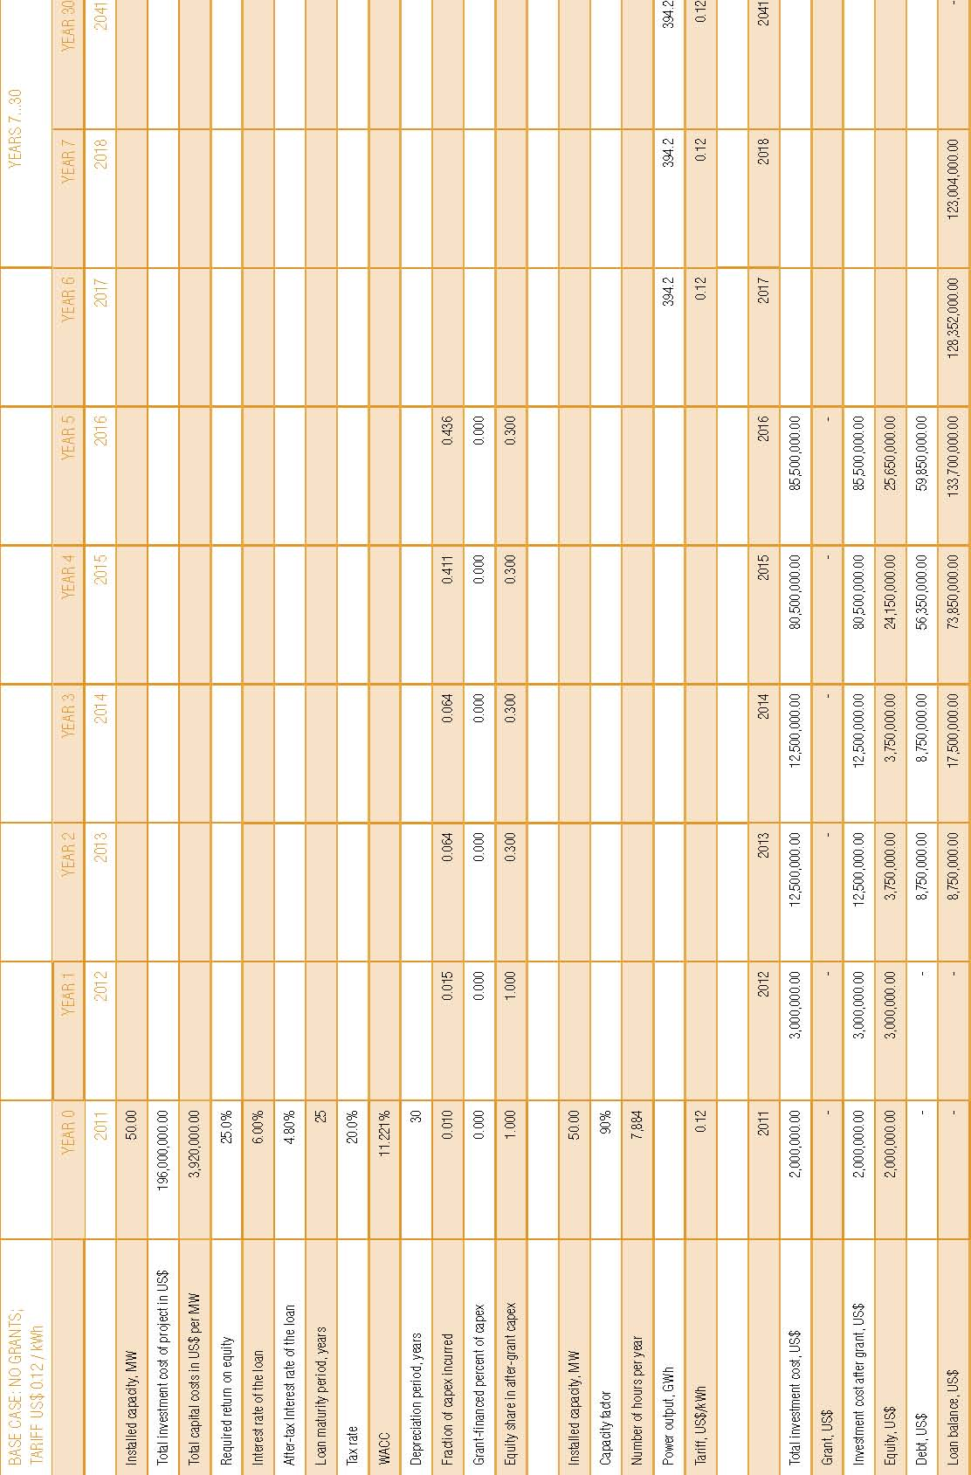

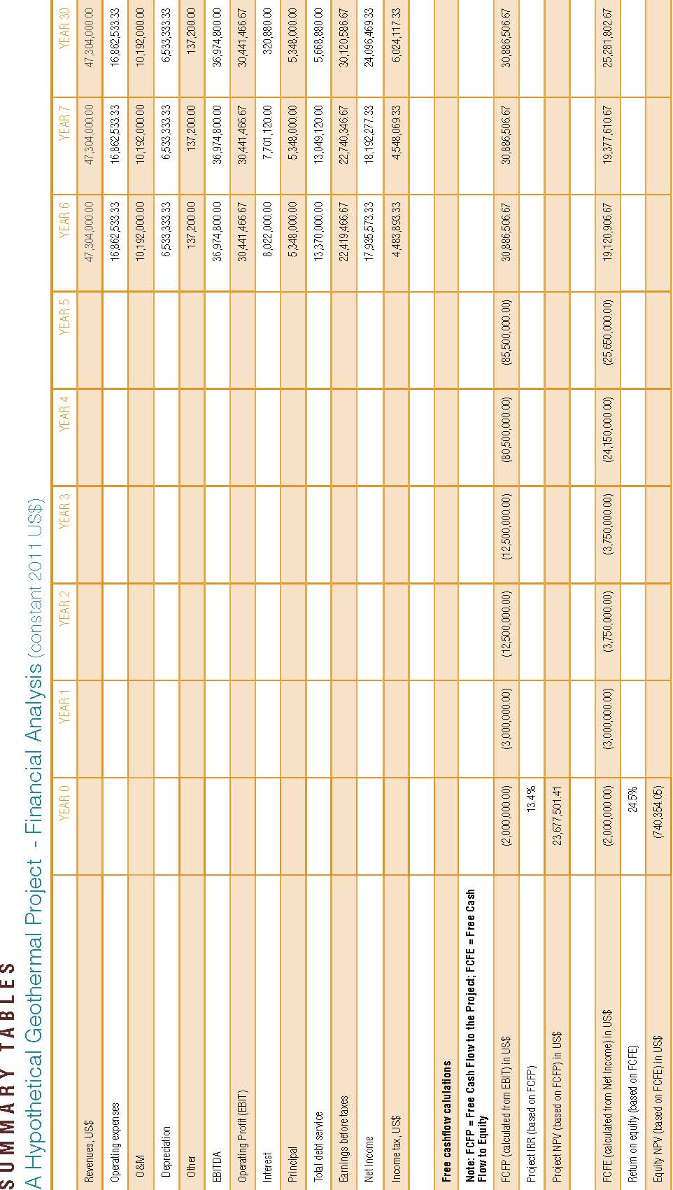

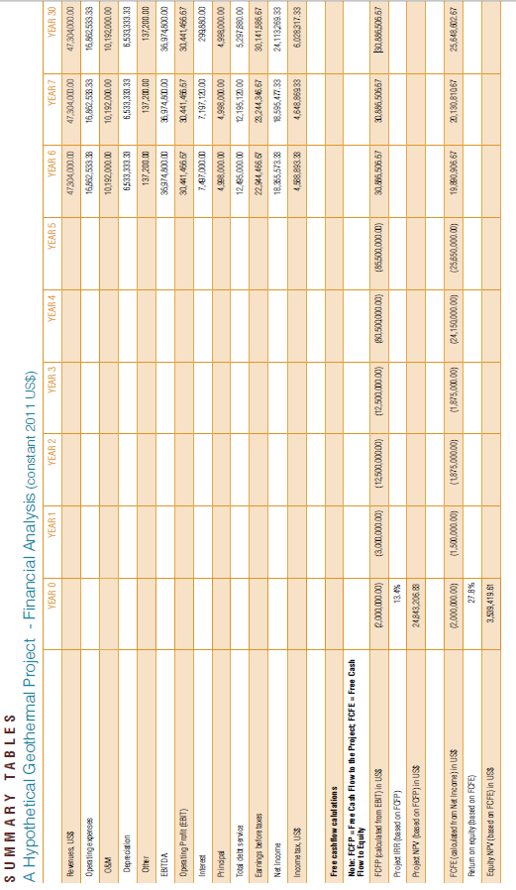

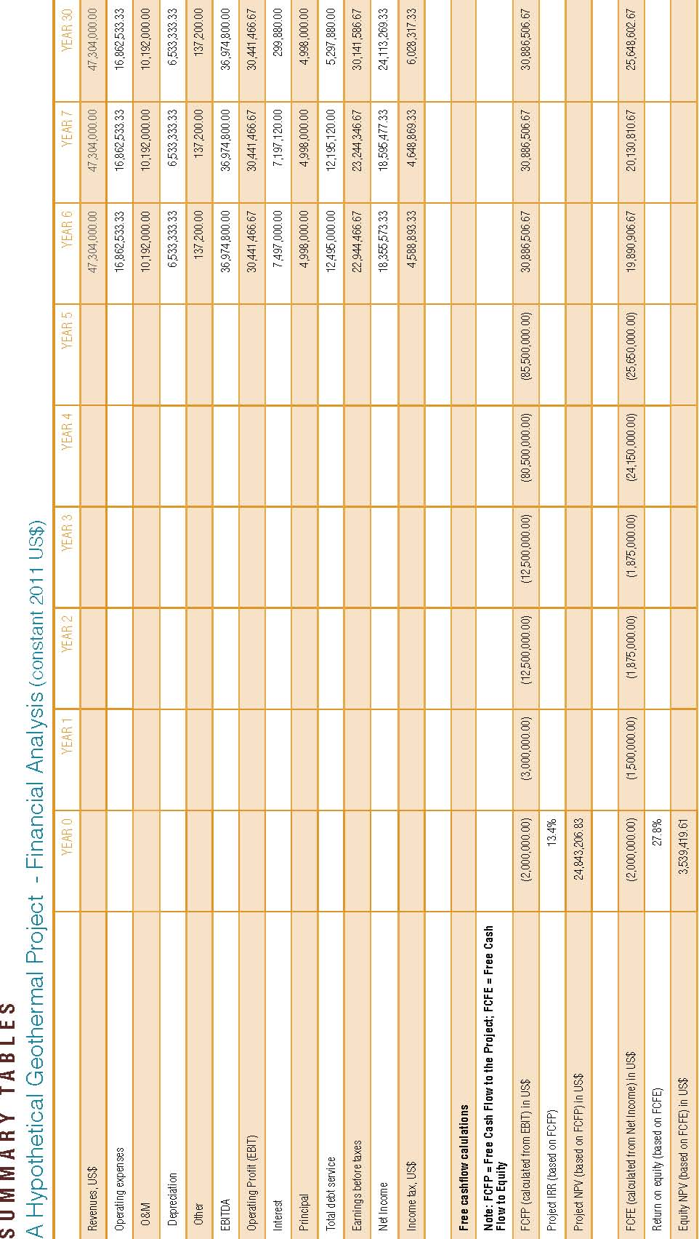

**SENSITIVITY ANALYSIS**

Various risk assessment tools can be employed in investment project analysis. Sensitivity analysis is one of them. To make the decision to commit resources to a project, the investor needs to be satisﬁed that the return on the investment is sufﬁciently robust under various scenarios affecting key parameters, such as the capital (investment) cost of the project, the recurring costs of operation and maintenance (O&M), and the likely level of tariff received per kilowatt hour sold to the grid, as well as the capital structure and terms of ﬁnancing of the project.

To assess the likely impact of these key parameters on the investor’s return, sensitivity analysis is typically performed. This type of analysis is sometimes called “what-if” analysis because it shows what happens to the key variable of interest to the investor if another variable (or, rather, its assumed value) changes. The variables whose impact is being determined are usually changed one at a time (although several variables can also be changed simultaneously to see their cumulative impact). If this approach is chosen, each variable is returned to the initial value assigned to it in a certain reference scenario before proceeding with the next variable. Such an analysis usually requires a cash ﬂow model to be sufﬁciently accurate. The example above was calculated using an Excel spreadsheet model that simulates the cash ﬂows to the equity investor.

**ANNEX 2, FIGURE 1**

Sensitivity of Return on Equity to Various Levels of Investment Costs and Electricity Sales Price (Tariff)

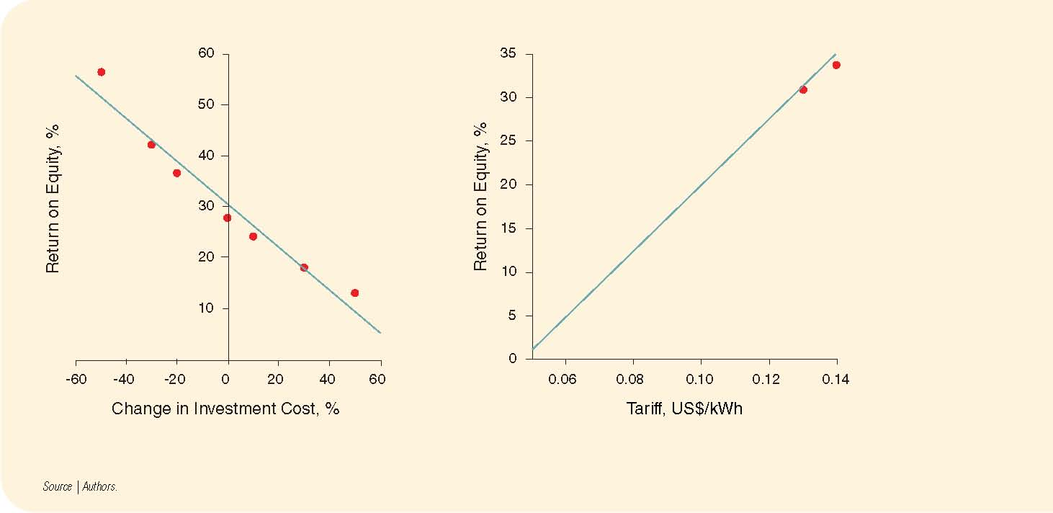

Given the uncertainty about the investment cost per megawatt eventually incurred by the project, it helps to review the impact of a deviation of the investment cost from the reference case. Using the Government Support Case (see Chapter 3), the graph shown in Annex 3, Figure 1 on the left side illustrates that a cost overrun of 20 percent would reduce the return on equity from about 28 percent to about 21 percent.

The graph on the right shows that, while a tariff of US$ 0.09 per kWh allows the investor to achieve a 17 percent rate of return, it would take US$ 0.11 per kWh or higher to achieve a 25 percent return on equity. One can observe that the relationships illustrated above are not exactly linear, but the sense of direction is clear.

The key ﬁndings from analyzing the impact of other variables can be summarized as follows.

* If the interest rate on the loan changes from 6 to 10 percent, the return on equity falls from 28 percent to about 24 percent.
* If the equity share in the project capital costs changes from the 30 percent assumed in the the reference scenario to 50 percent (after Year 2, since we are assuming the ﬁrst two years’ investments will have to be entirely equity-ﬁnanced), the return on equity falls to about 21 percent. Conversely, if the share of equity is decreased to 20 percent, the return on equity reaches 33.5 percent. This is due to the leverage effect of the loan that replaces equity in the capital structure by the same amount that equity decreases.
* If the capacity factor of the power plant is assumed to be 70 percent instead of 90 percent, the return on equity the return on equity falls to 18.5 percent.
* If the O&M costs prove to be 50 percent higher than envisaged in the reference scenario, the return on equity will fall from 28 percent to 23.5 percent; on the other hand, if the O&M costs turn out to be 50 percent below the reference scenario, the return on equity is close to 32 percent.

It bears repeating that these results of the “what-if” simulation are built around the Government Support Case which includes partial grant ﬁnancing in the early years of the project. The impact from excluding the grants from the calculation negatively affects the return on equity, and the results of the sensitivity analysis would be affected as well. Unless other factors intervene (for instance, if the tariff in the Base Case is set at a higher level than in the Government Support Case), all the curves describing the relationships of the input parameters with the return on equity would shift downward by a few percentage points.

Return on equity is not the only key ﬁgure that may be of interest to the investor, and sensitivity analysis may be conducted for many other dependent variables. For example, since the equity investor is typically not the only investor in the project, the return on the project as a whole may be as important as return on equity. A cash ﬂow model for return on the project as a whole would be based on the same investment cost and operational data, but would focus on the cash ﬂow available to all investors, including providers of debt ﬁnancing. The rate of return calculated on this basis will often be lower than the return on equity (due to the positive leveraging effect of debt in the latter case), but this does not necessarily make the project less attractive since the required return would also be lower on average. The process for the sensitivity analysis would be essentially the same.

Besides the two measures of return mentioned above, other variables could lend themselves to a meaningful sensitivity analysis. In addition, it should also be kept in mind that the ﬁnancial model used above does not substitute for an economic analysis of the project or for a power systems expansion analysis. The three are all needed for various purposes of developing a geothermal investment program, that is: (a) optimizing the size of a particular geothermal investment from the overall system’s perspective; (b) understanding the economic merits of a geothermal investment from a societal cost point of view; and (c) understanding the impacts of key ﬁnancial assumptions, including costs of capital and ﬁnancing structures—on the required tariffs and incentives to private sector developers of a speciﬁc investment.

1. [Ley General de Cambio Climático](http://www.diputados.gob.mx/LeyesBiblio/pdf/LGCC.pdf), 2012.
2. INECC. [Bases para una estrategia de desarrollo bajo en emisiones de México](http://bit.ly/BEDBEMex). 2012.
3. Levelized Energy Cost (LEC) is the price at which electricity must be generated from a specific source to break even over the lifetime of the project. It is an economic assessment of the cost of the energy-generating system including all the costs over its lifetime: initial investment, operations and maintenance, cost of fuel, [cost of capital](http://en.wikipedia.org/wiki/Cost_of_capital), and is very useful in calculating the costs of generation from different sources.
4. The analysis considers it appropriate to compare geothermal to other renewable energy technologies. Fossil fueled electricity generation is not considered, as its costs do not reflect the externalities associated to the use of those over clean technologies.
5. Approximate US dollar value of 150 million Mexican pesos, using an average conversion rate of 13 Mexican pesos per US dollar.
6. CTF amounts used may vary from the ones indicated in the POD, as those incorporate deductions due to MDB fees. Possible differences are considered to be marginal and irrelevant with regards to this analysis.
7. The load capacity factor of a [power plant](http://en.wikipedia.org/wiki/Power_plant) is the ratio of its actual output over a period of time, to its potential output if it were possible for it to operate at full [nameplate capacity](http://en.wikipedia.org/wiki/Nameplate_capacity) indefinitely.
8. It is expected the installation of 358 Mw and a withdrawal of 225 Mw
9. Benderitter and Cormy. [Classification of Geothermal Resources](http://idbdocs.iadb.org/wsdocs/getDocument.aspx?Docnum=38271052). 1990.
10. Instituto de Investigaciones Eléctricas. [Primera estimación de las reservas geotérmicas de México](http://idbdocs.iadb.org/wsdocs/getDocument.aspx?Docnum=38271053).2009.

    CFE. [Potencial geotérmico de la República Mexicana](http://idbdocs.iadb.org/wsdocs/getDocument.aspx?Docnum=38271054). 2011.

    CFE-BID. [Evaluación de la Energía Geotérmica en México](http://idbdocs.iadb.org/wsdocs/getDocument.aspx?Docnum=38207661). 2011.
11. Worldwide, these costs are in the range of US$2 million and US$4 million per MW for a condensing flash plant and US$2.4 million and US$5.9 million per MW for a binary plant (IEA).
12. The levelized cost of electricity generated by different sources is a calculation of the cost of [generating](http://en.wikipedia.org/wiki/Electricity_generation) [electricity](http://en.wikipedia.org/wiki/Electricity) at the point of connection to a load or electricity grid. It includes the initial [capital](http://en.wikipedia.org/wiki/Capital_(finance)), [discount rate](http://en.wikipedia.org/wiki/Annual_effective_discount_rate), as well as the costs of continuous [operation](http://en.wikipedia.org/wiki/Operating_costs), [fuel](http://en.wikipedia.org/wiki/Fuel), and [maintenance](http://en.wikipedia.org/wiki/Maintenance,_repair,_and_operations). This type of calculation assists policy makers, researchers and others to guide discussions and decision making.
13. [Iniciativas para el desarrollo de las Energías Renovables en México](http://idbdocs.iadb.org/wsdocs/getDocument.aspx?Docnum=38271055). This cost is conservative since the actions carry out by the program will impulse the development of geothermal energy reducing it cost to 74 USD/Mwh
14. Costos y parámetros de referencia para la formulación de proyectos de inversión en el sector eléctrico en México. CFE 2012.
15. Average load capacity in Mexico is 84%. Gutiérrez-Negrin et al., [Current Status of Geothermics in Mexico](http://geotermia.org.mx/geotermia/pdf/Mexico-2010.pdf). 2010
16. SENER. [Prospectiva del Mercado de Gas Natural 2012-2026](http://idbdocs.iadb.org/wsdocs/getDocument.aspx?Docnum=38271060). 2011.
17. [Point Carbon, Carbon Market Daily](http://idbdocs.iadb.org/wsdocs/getDocument.aspx?Docnum=38271057), November 29, 2013.
18. CTF amounts used may vary, as the ones indicated do not incorporate deductions due to MDB fees. Possible differences are considered to be marginal and irrelevant with regards to this analysis.
19. The overall leverage ratio of the facility requires that the CTF resources be matched with at least equal amounts from the IDB CCLIP and from NAFIN’s own resources. IDB co financing may come from resources approved under this operation or from the remainder of the previous approved operation under the CCLIP, the Renewable Energy Financing Facility (REFF) ME-L1119.
20. Approximate US dollar value of 150 million Mexican pesos, using an average conversion rate of 13 Mexican pesos per US dollar. Additional NAFIN’s own resources will be used for financing of Component II and will be determined for each project on a case-by-case basis.
21. Quantification of the macroeconomic impact has been carried out using the Input-Output methodology, based on the latest Input-Output matrix prepared by the INEGI (Instituto Nacional de Estadística y Geografía de México). Click [here](http://idbdocs.iadb.org/wsdocs/getDocument.aspx?Docnum=38271056).
22. Solar energy, tidal energy, osmotic power, wave power, hydro power, and wind power.
23. Approximate US dollar value of 150 million Mexican pesos, using an average conversion rate of 13 Mexican pesos per US dollar.
24. This affects directly to the electricity generated since its Mwh are reduced by a 70.4%.